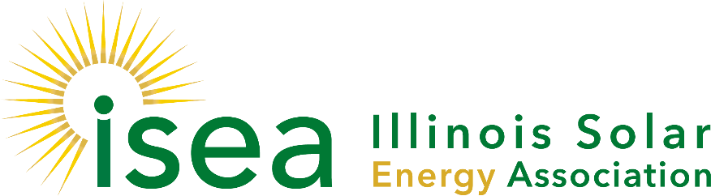

**Contract Position:**

**ISEA Online Permitting Outreach Lead**

The Illinois Solar Energy Association is seeking an experienced individual to introduce and expand online solar permitting across Illinois. This part-time, contract position will involve working directly with local permitting authorities to promote the adoption of an online permitting platform that can reduce costs and help expand solar installations throughout the state.

**Background:** Securing construction permits for solar installations can be time-consuming and costly for businesses and residents, making permitting one of the largest “soft-costs” facing the solar industry today. Moving jurisdictions to online permitting can greatly reduce staff time and reduce costs, helping to smooth the transition to a clean energy economy.

Numerous jurisdictions now offer online or electronic permit applications, but none offer instantaneous permits. Typically jurisdictions take 48-72 hours for approval, but the range between jurisdictions can be drastic. Likewise, it is not uncommon for installers to wait weeks for an inspection.

To meet this challenge, ISEA has received a grant to promote SolarAPP, an online solar permitting platform created at the National Renewable Energy Laboratory.

**Position Details:** The Outreach Coordinator will work directly under ISEA’s Executive Director to educate municipalities (villages, towns, cities, counties) about the value SolarAPP can bring to Illinois communities.

The ideal candidate will have direct experience in local-level solar permitting and will work closely with the ISEA’s Legislative Lead, Board of Directors and other contractors as needed. The Outreach Lead will work approximately 30 hours/week on this project from March 1 - Dec 31, 2021. This is a fully remote position, although some in-person meetings may be required later in the year.

Specific duties will include:

* Meeting with local-level officials (city managers, permitting departments, etc.) to explain the benefits of SolarAPP and encourage the jurisdiction to adopt SolarAPP as their primary permitting system for solar installations.
* Engage with thought leaders in the state, including the 42 municipalities that have already received SolSmart designation from the US Department of Energy, as well as the Metropolitan Mayors Caucus and others
* Develop local-level champions for SolarAPP and work with these early-adopters to encourage peers at other Illinois jurisdictions to adopt the software as well.
* Assist jurisdictions in implementing SolarAPP in their communities

To respond to this position please send your resume and cover letter to [Lesley.mccain@illinoissolar.org](mailto:Lesley.mccain@illinoissolar.org) using the subject line –SolarAPP Consulting Position