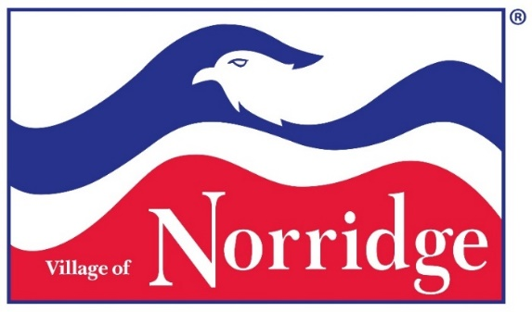
JOB OPENING
Job Title: Full-Time Building Commissioner (Village Staff Dept. Head)
Department: Building Department
Reports To: Village Administrator

Date of Posting: February 1, 2023

Located in Cook County, Illinois, the Village and its neighbor to the east, Harwood Heights, together form an enclave within the City of Chicago (i.e. they are completely surrounded by the city). Norridge is sometimes referred to as the "Island Within a City". Norridge’s population stands at 15,251 residents. The Village infrastructure covers an area of two square miles. It has 31.65 miles of streets, 55 miles of sidewalks and over 5,727 homes, and 3,991 families residing in the Village.
The Village of Norridge operates under the Village Trustee form of government and has a Village President and 6 Trustees. There is a strong commitment to professional management within the organization. The Village Administrator is contracted for appointment with the consent of the Village Board. Norridge’s workforce is 65 full-time employees, 25 part-time employees, and 30 members on various boards and commissions. There are seven Department Heads. Departments include Administration, Finance, Police, Water, Public Works, Building/Health, and Village Properties.
The Village seeks its next Building Commissioner to lead a well-respected and professional Department. The Building Commissioner is appointed by the Village President, with concurrence of the Village Trustees, and reports to the Village Administrator. The Building Commissioner directs and oversees the work performed by the Building Department, including Code Enforcement and Health Department. The Building Department plays an important role in promoting property safety while creating a customer friendly environment that encourages both businesses and families to locate here.
The Building Commissioner’s responsibilities include enforcing or directing enforcement and assuring compliance of all building codes and related municipal codes and county, state and federal laws. The Building Commissioner will regulate and control the design, construction, use, occupancy and maintenance of structures within the Village. The Building Commissioner must also coordinate assigned activities with other Village Departments and outside agencies.
The Building Commissioner works under the supervision of the Village Administrator. The Building Commissioner is responsible for reviewing, inspecting, and approving all new residential construction projects and small commercial remodeling and has final approval on all third party plan review projects. The Building Commissioner will make recommendations for the updating of codes, ordinances, and the permitting process. The Building Commissioner is an integral part of the Village's executive leadership team, collaborating with the other Department Heads and staff on interdepartmental issues.
CANDIDATE QUALIFICATIONS AND EXPECTED EXPERIENCE:
The successful candidate will have the following qualifications and experiences. Any combination of experience and training that would demonstrate the required knowledge and abilities is qualifying.
- Valid Driver’s License.
- High School Diploma or equivalent.
- Minimum of Associates Degree in building construction, architecture, engineering or related field.
- Minimum 4 years of experience with Municipal Building Department operations.
- Minimum of 2 years of experience with supervising 5 or more employees.
- Knowledge of Village, County, State and Federal laws and regulations.
- Ability to read Building Plans/Blueprints and Plats of Survey.
- Thorough knowledge of building construction, including a minimum of 4 years of experience in building plan review, inspections and permit processing, or related construction industry work, preferably with supervisory or management experience, or any equivalent combination of training and experience.
- Must have or be able to learn within 6 months of employment, Norridge streets, zoning codes and the Zoning map.
- Knowledge of health and sanitation codes.
- Must be able to effectively communicate orally and in writing with employees, other supervisors and department heads, public officials, vendors, contractors and Village residents.
- Must be able to exercise sound judgement and make decisions.
- Strong commitment to excellent customer service.
- Must be a team player and highly collaborative.
- Ability to lead and direct employees in achieving assignments.
- Embrace, implement and use innovative technology.
- Must be proficient in Microsoft Word, Excel & Outlook.
- Must be able to use computer systems and software which the Village utilizes for operations.
- Subject to random drug and alcohol testing.
- Operate a Village vehicle.

COMPENSATION AND HOW TO APPLY:
The annual salary range is $75,000-$95,000 depending on qualifications and years of relevant municipal service. Position comes with excellent benefits. The Village of Norridge is an equal opportunity employer and is committed to diversity in the workplace.
The Building Commissioner position is open until filled. If you would like to be considered for this opportunity, you must remit all required paperwork (cover letter, resume, and a list of five references) by 12:00 PM on March 6, 2023.
Interested candidates must submit required paperwork (cover letter, resume, and a list of five references) in confidence via email to Employment_App@villageofnorridge.com
Applicants for this position who are selected as finalists will be subject to a background screening. Pre-employment process following conditional job offer will include a full background investigation, including but not limited to drug and alcohol screening, physical examination, and psychological evaluation. References will be contacted only following candidate approval. If you have questions about this process, email or call Village Administrator Joanna Skupien
(708-453-0800 - jskupien@villageofnorridge.com)

